### Table Of Content:

0. Important Links

1. Data Types
2. Void main() vs Int main()
3. Behind the scenes and compiling
   1. Linker and Loader
   2. Macros and Preprocessors
   3. 32 Bit vs 64 bit gcc
   4. Platform dependency and independency.
   5. Internal and External linkage
   6. How compilation of prog takes place.
4. Error and Exception
5. Error handling
6. Scope
7. Functions
   1. Static functions
   2. Overloading
   3. Call back functions
8. Pointers
   1. Types
   2. Double Pointer
   3. Reference and dereference
   4. Pointer to Function
   5. Void / Null / Dangling / Wild
   6. Near / Far / Huge
   7. Restrict keyword
9. Storage class
   1. Static keyword
   2. Volatile
   3. Register
10. Enum, struct and Union
11. Bit Fields
12. Malloc and Calloc
13. Deallocation of memory
    1. With free
    2. Without free
14. Operators
15. Precedence Table
16. File Handling
17. Preprocessor Directive
18. _Generic Keyword
19. Multithreading
20. Assertion
21. Control Statement
    1. If else
    2. switch
    3. Goto
22. Hygienic Macros

### 

### 0. Important Links:

[Geeks for geeks - C](https://www.geeksforgeeks.org/c-programming-language/)

[2braces I/O Questions](https://www.2braces.com/c-questions/)

[Includehelp I/O Questions](https://www.includehelp.com/c/basic-input-output-aptitude-questions-and-answers.aspx)

### Data Types :

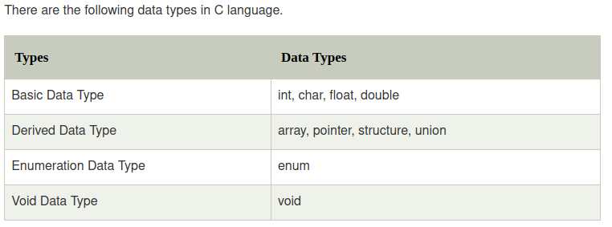

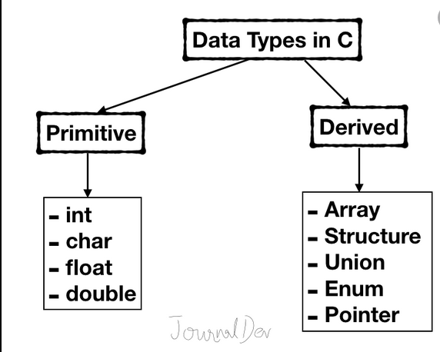

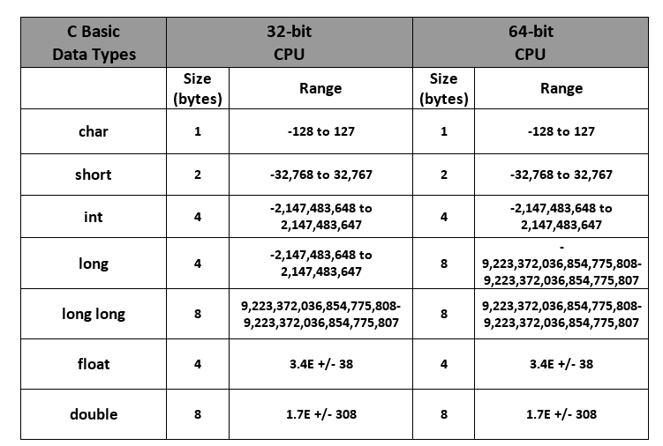

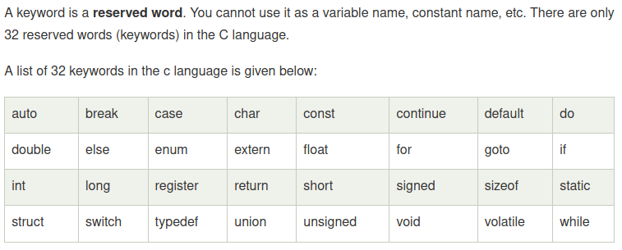

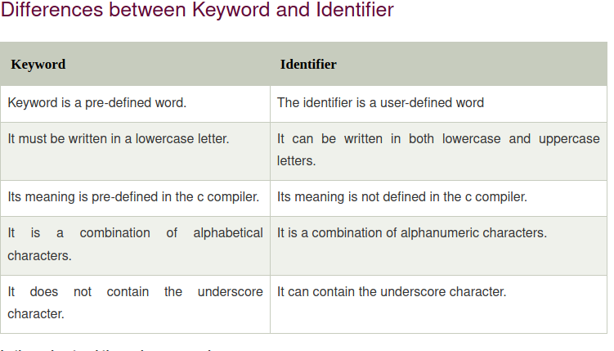

### Void main() vs Int main():

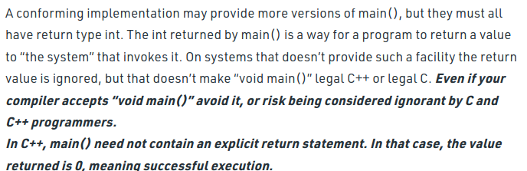

### Behind the scenes and compiling:

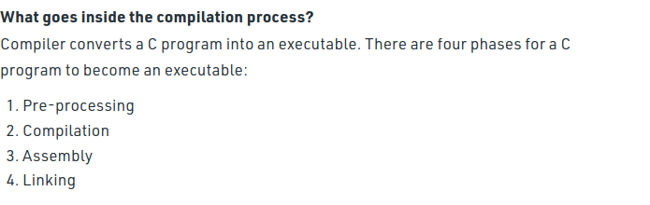

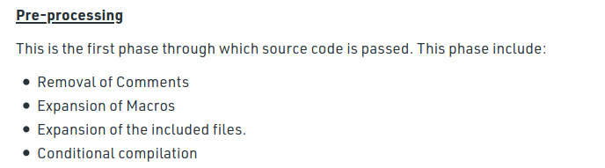

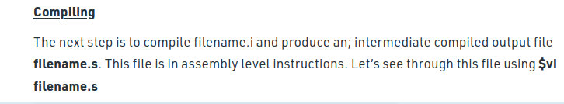

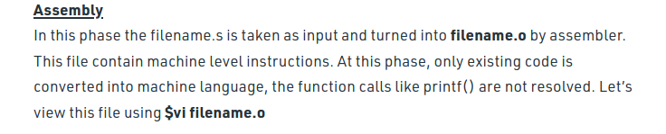

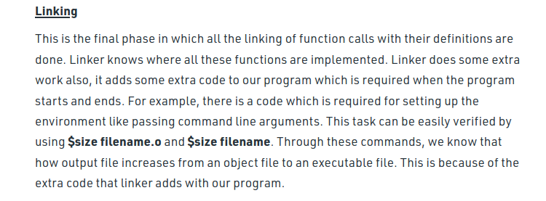

### Linker and Loader:

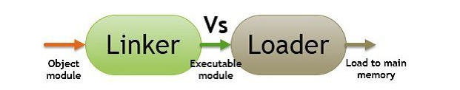

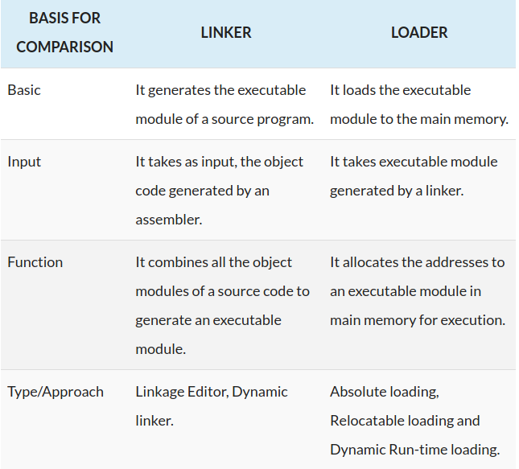

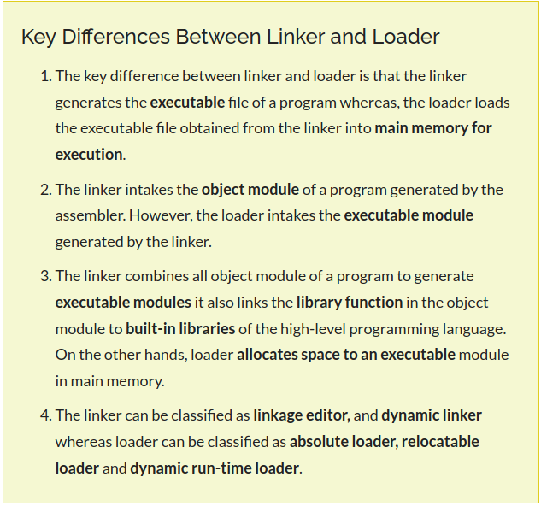

### Macros and Preprocessors:

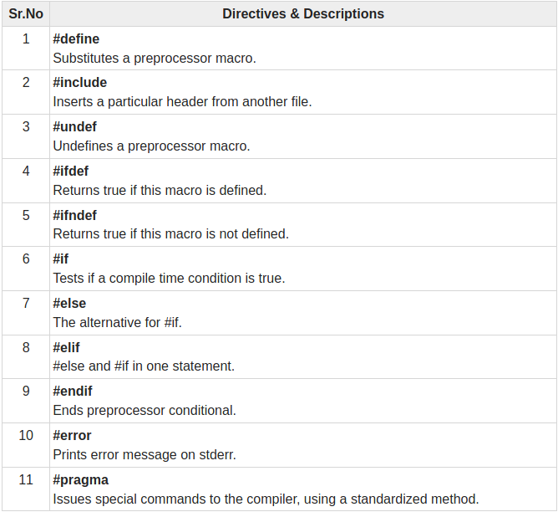

### 32 Bit vs 64 bit machine:

[Computerhope](https://www.computerhope.com/issues/ch001498.htm)

[Gfg](https://www.geeksforgeeks.org/difference-32-bit-64-bit-operating-systems/)

### Platform dependency and independency:

For the case of C and C++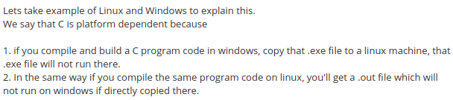

### Internal and External linkage:

### 

### Error and Exception:

Difference in Java :

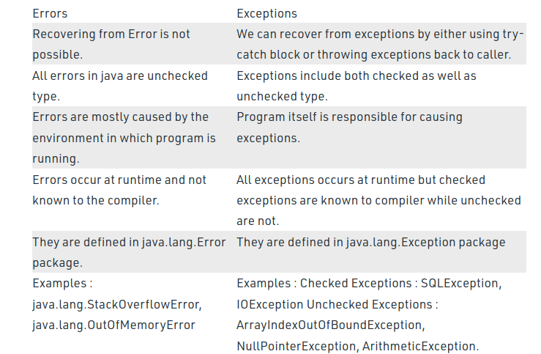

### Error handling:

### Scope:

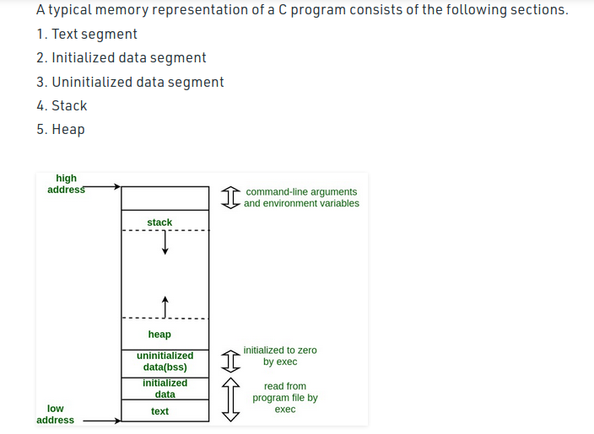

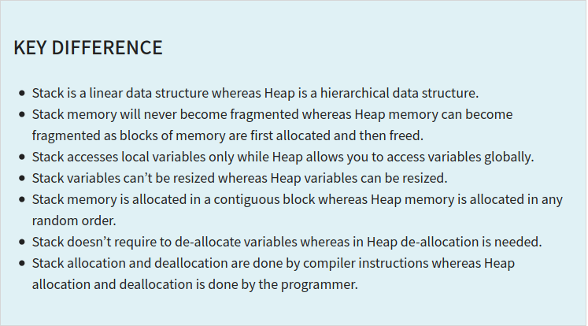

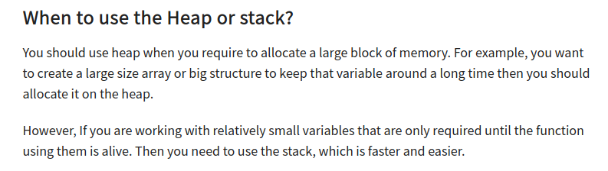

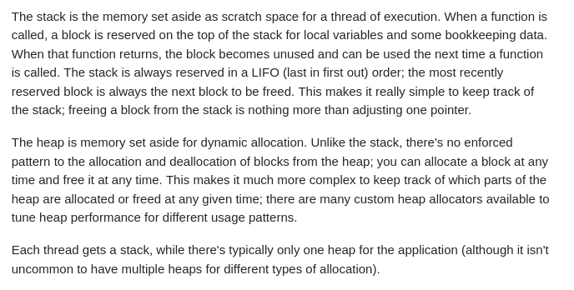

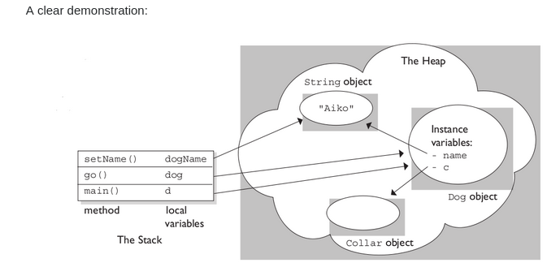

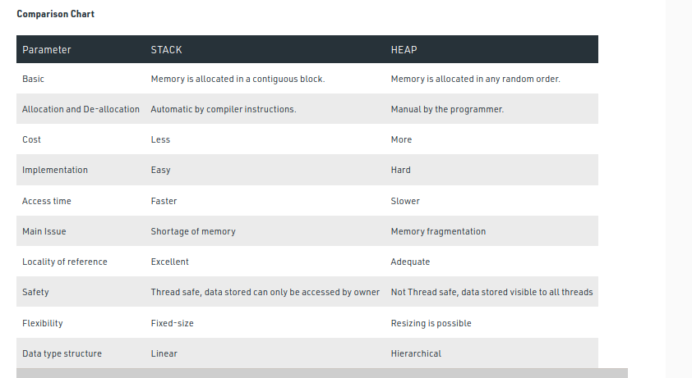

### Static keyword:

[Quiz on static](https://www.geeksforgeeks.org/c-plus-plus-gq/static-keyword-gq/)

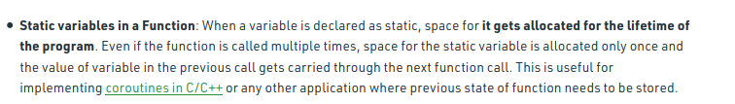

[Coroutines ?](https://www.geeksforgeeks.org/coroutines-in-c-cpp/)

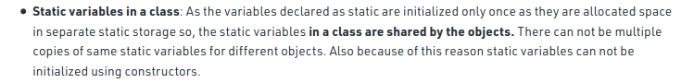

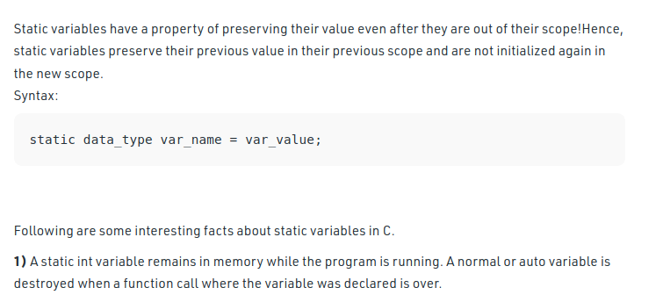

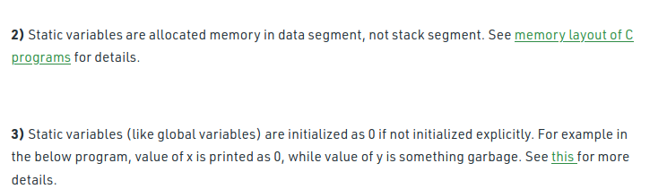

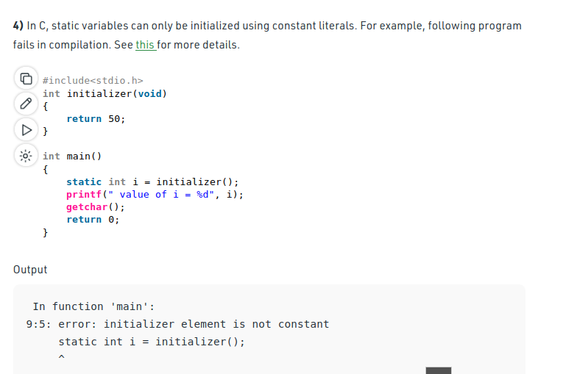

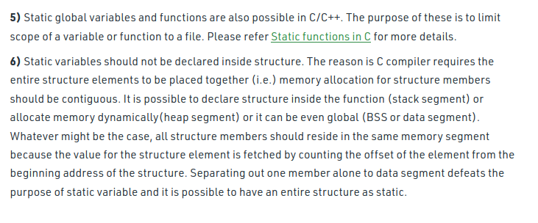

[Can static func be virtual in C++](https://www.geeksforgeeks.org/g-fact-29/)

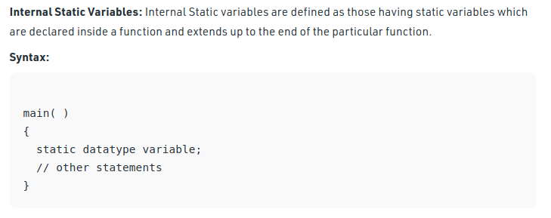



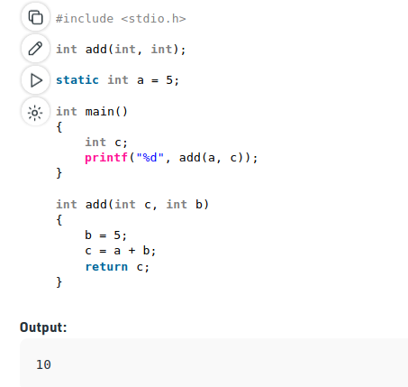

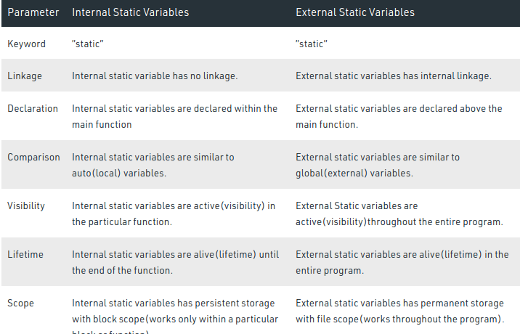

### Functions:

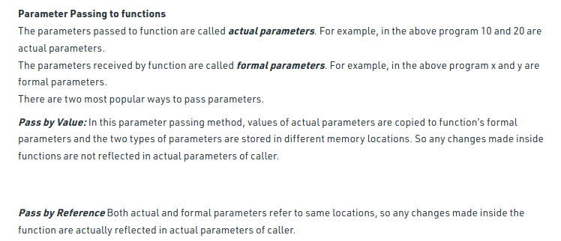

### Static functions:

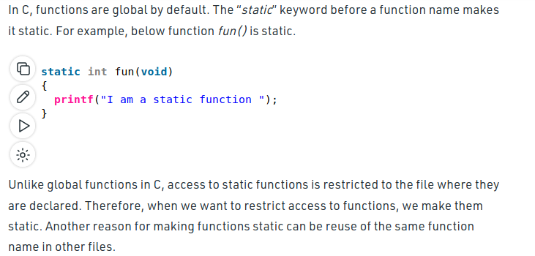

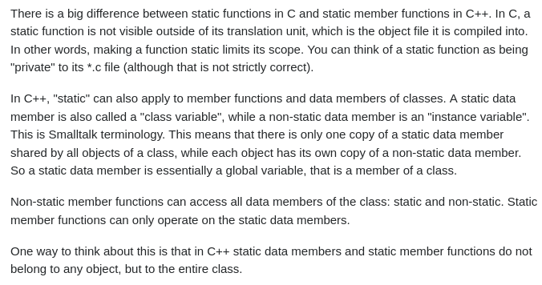

### Overloading:

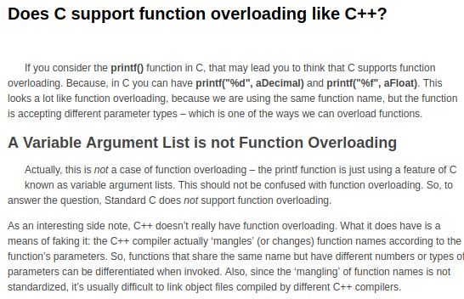

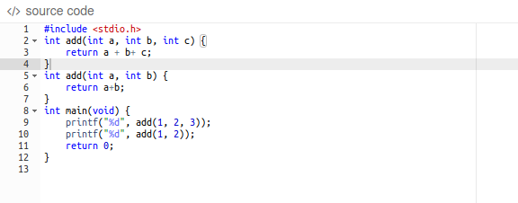

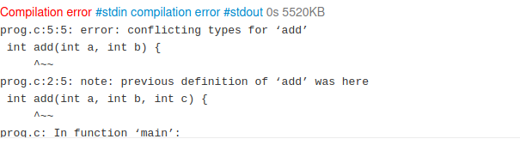

### Call back functions:

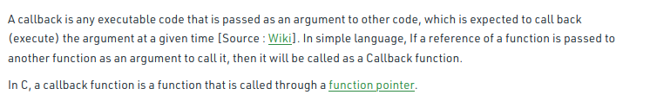

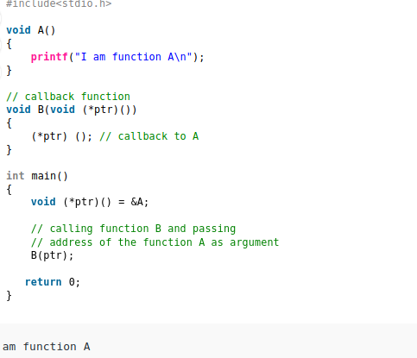

### _Generic Keyword:

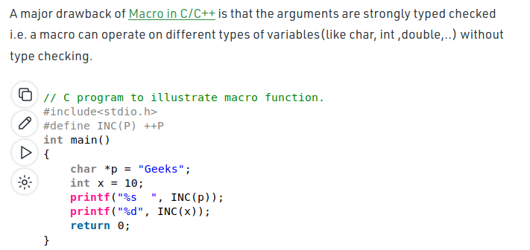

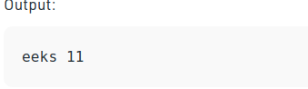

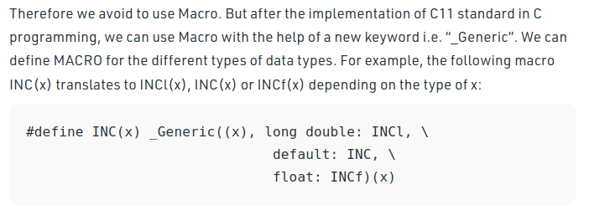

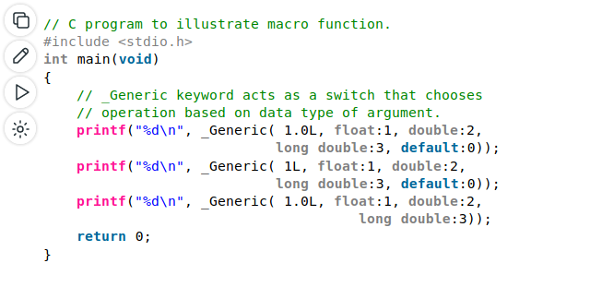

Output:

3

0

3

### Pointers:

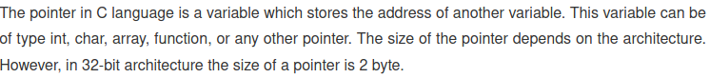

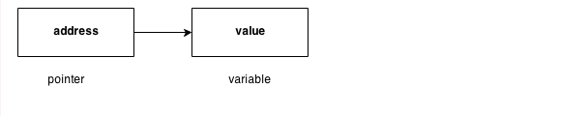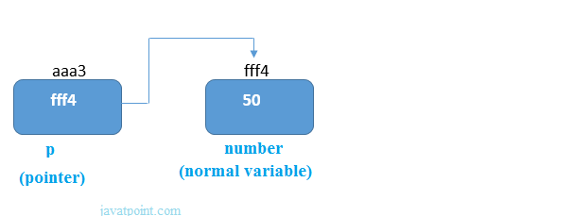

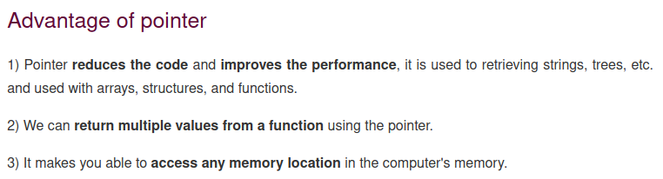

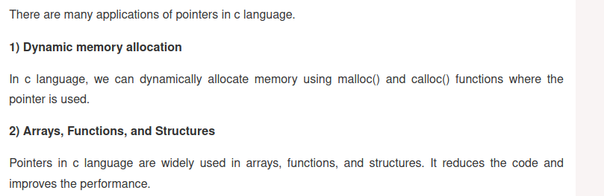

### Types:

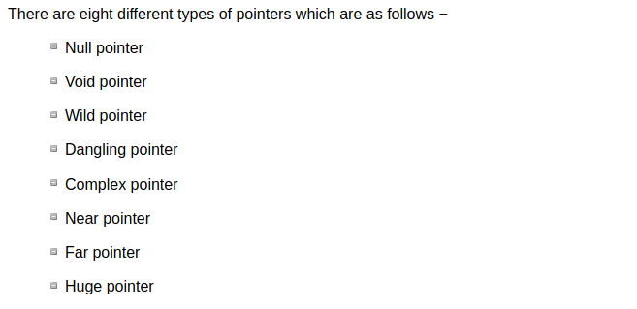

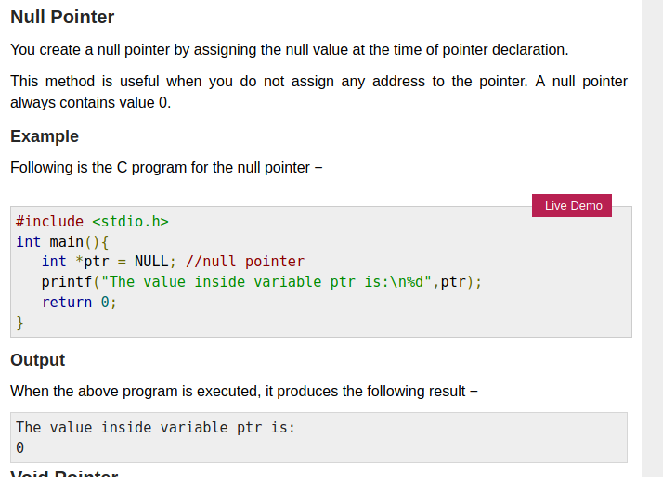

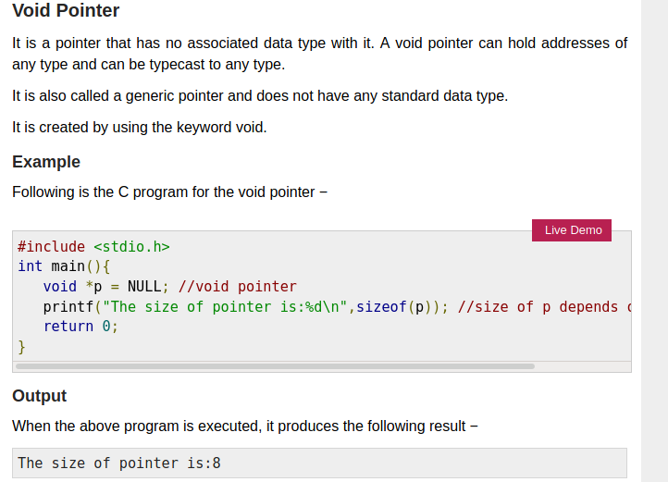

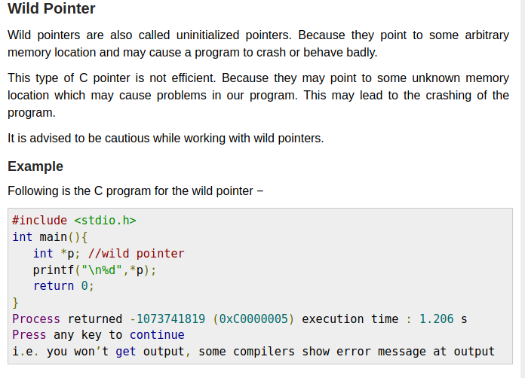

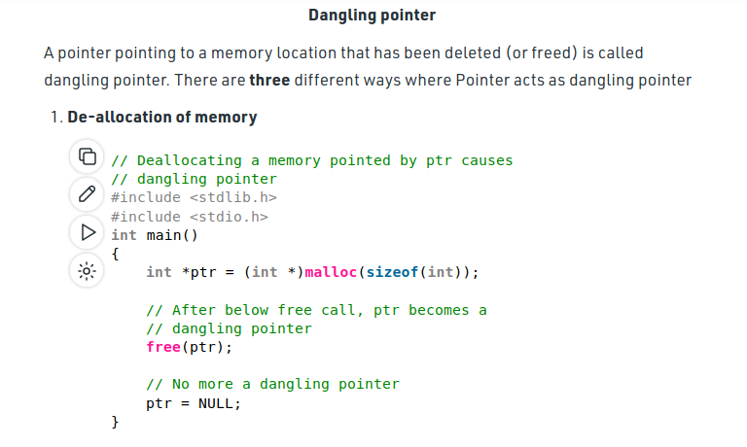

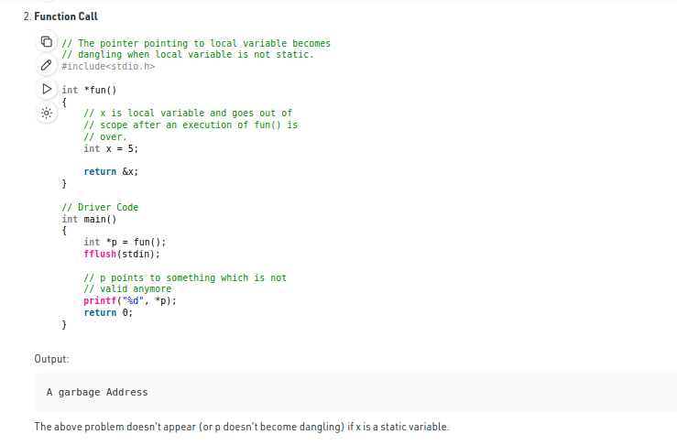

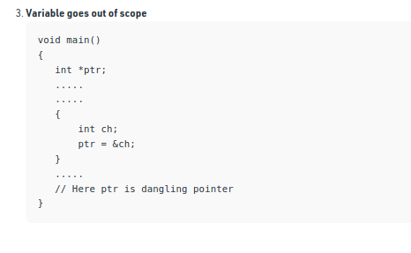

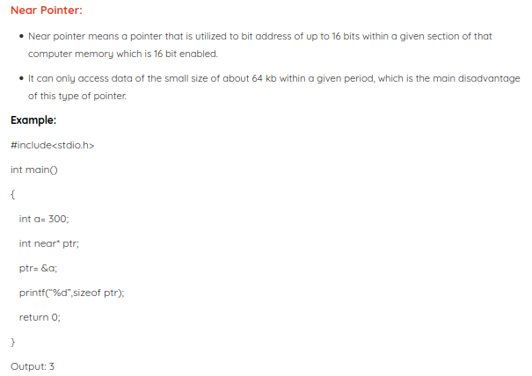

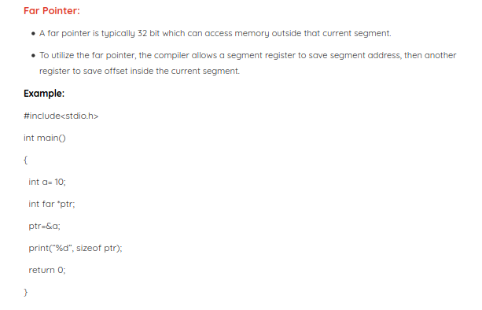

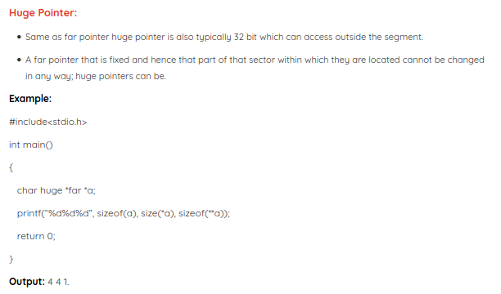

### Double Pointer:

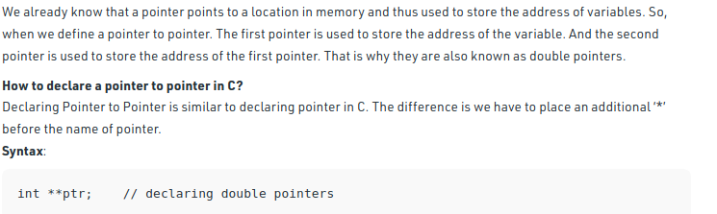

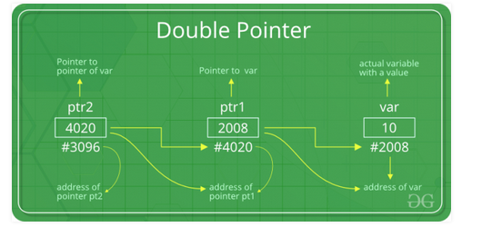

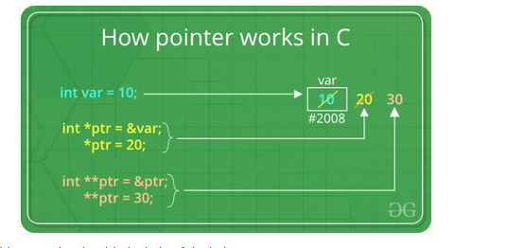

### Reference and dereference:

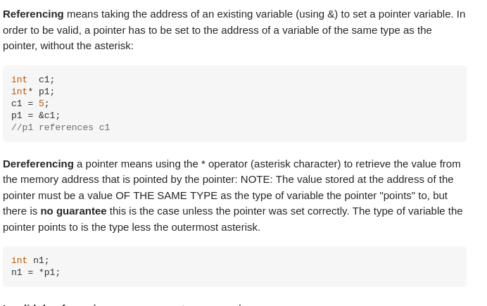

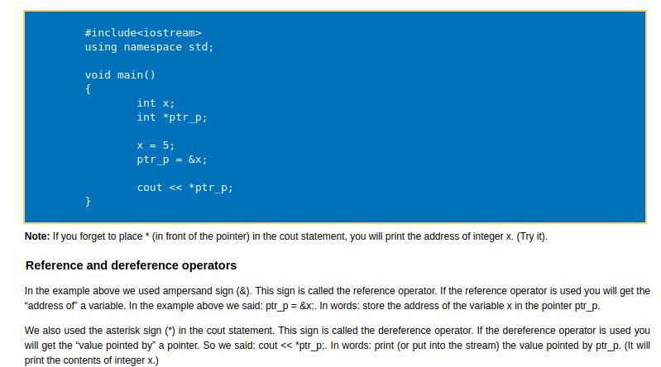

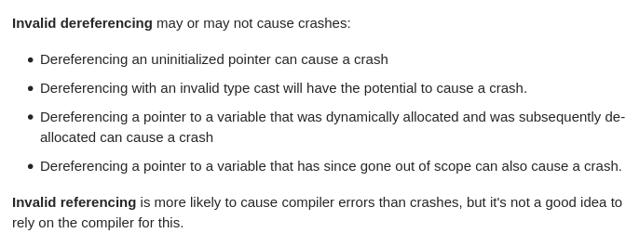

### Pointer to Function:

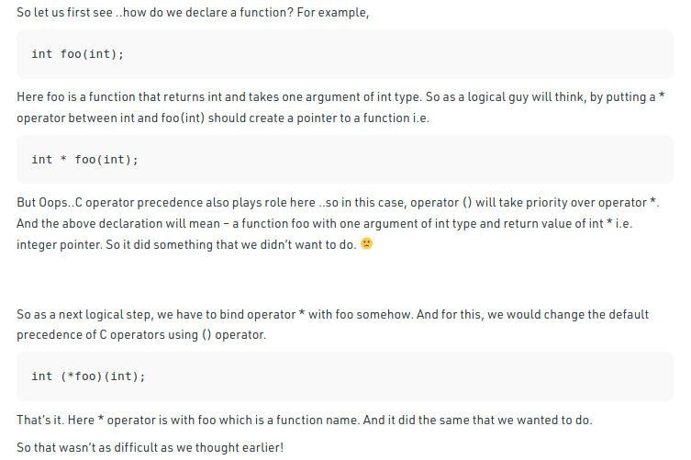

Function Pointer:

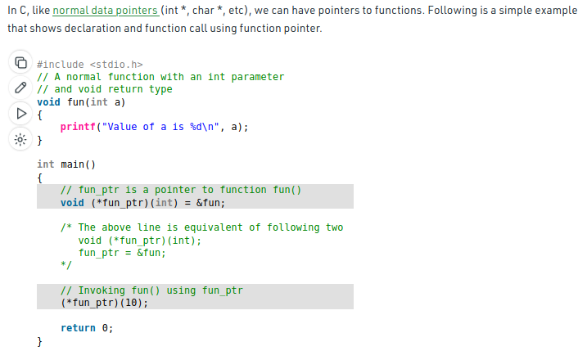

Output:

Value of a is 10



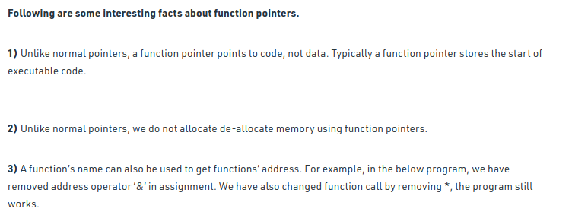

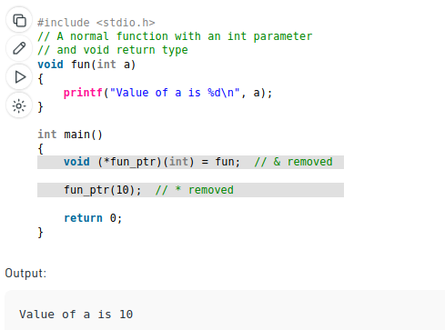

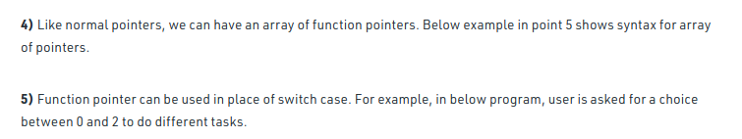

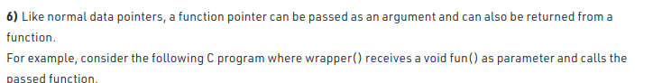

### Restrict keyword:

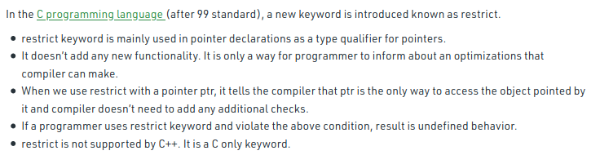

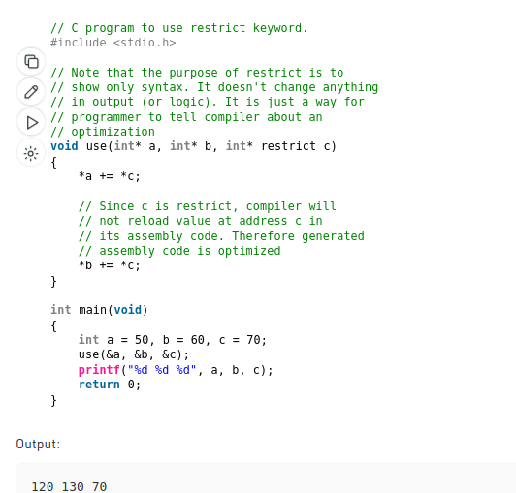

### Storage class:

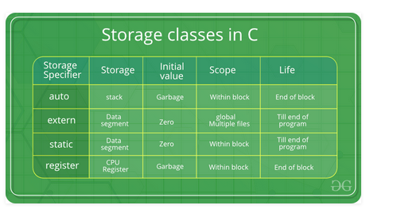

### Volatile:

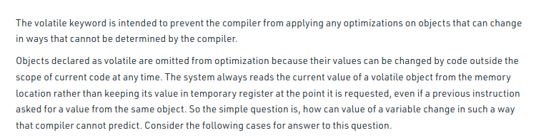

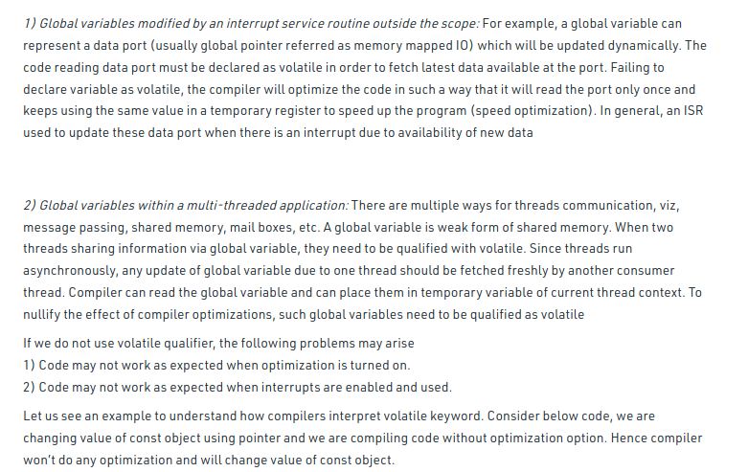

### Enum, struct and Union:

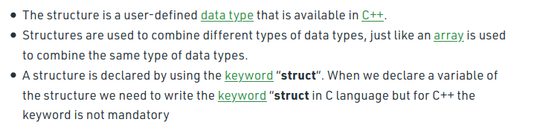

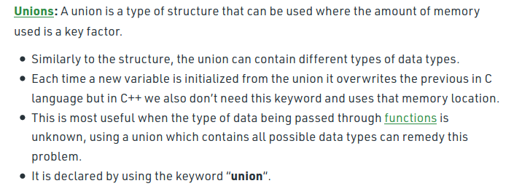

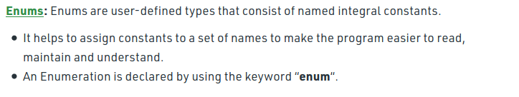

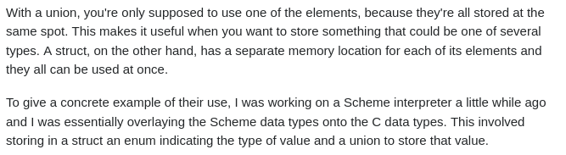

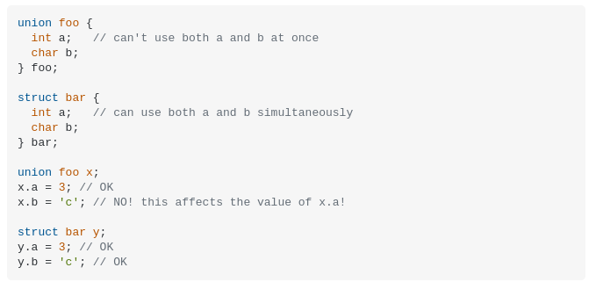

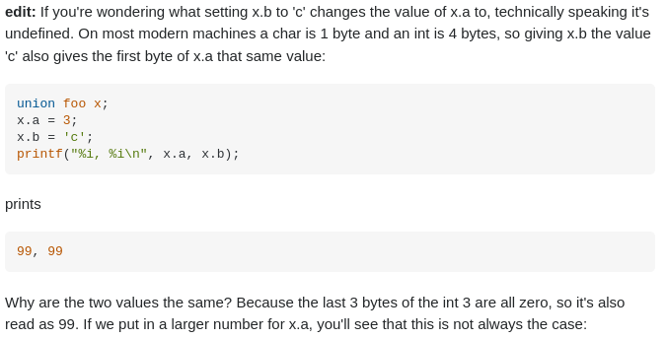

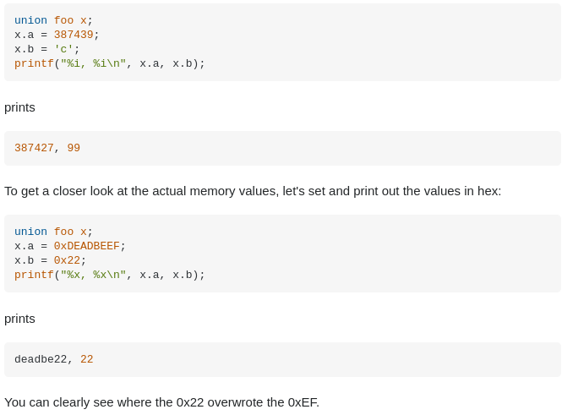

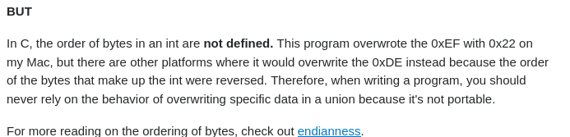

[Endianness](https://en.wikipedia.org/wiki/Endianness)

### Bit Fields:

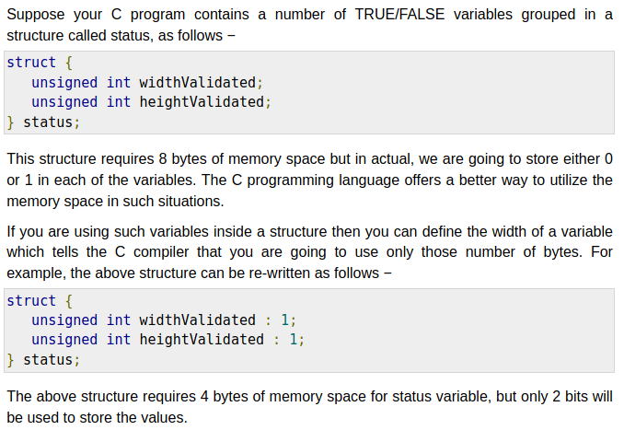

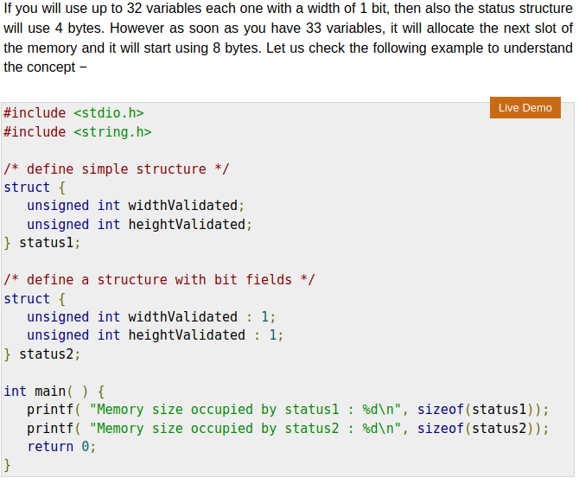

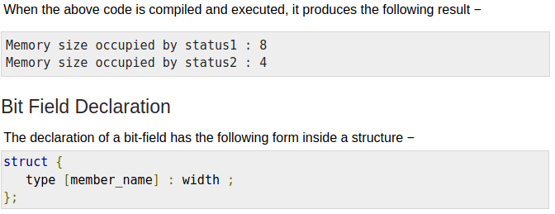

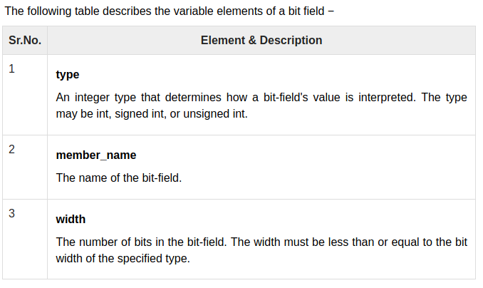

### Malloc and Calloc:

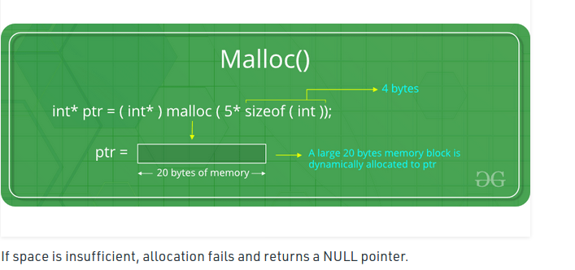

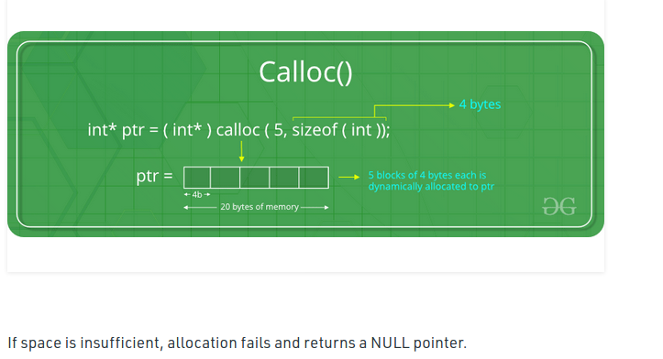

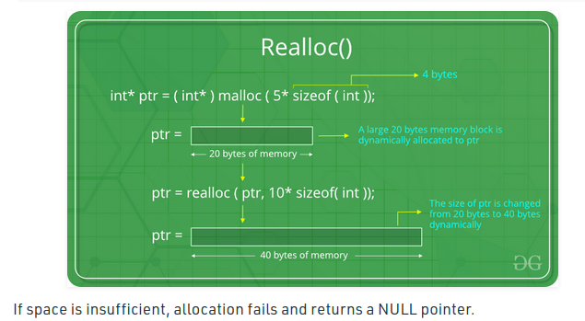

### Deallocation of memory:

### With free:

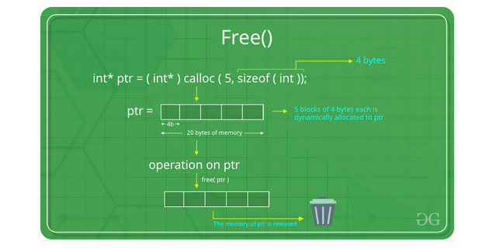

### Without free:

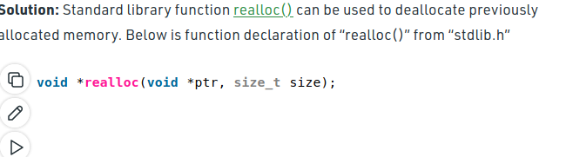

### Precedence Table:

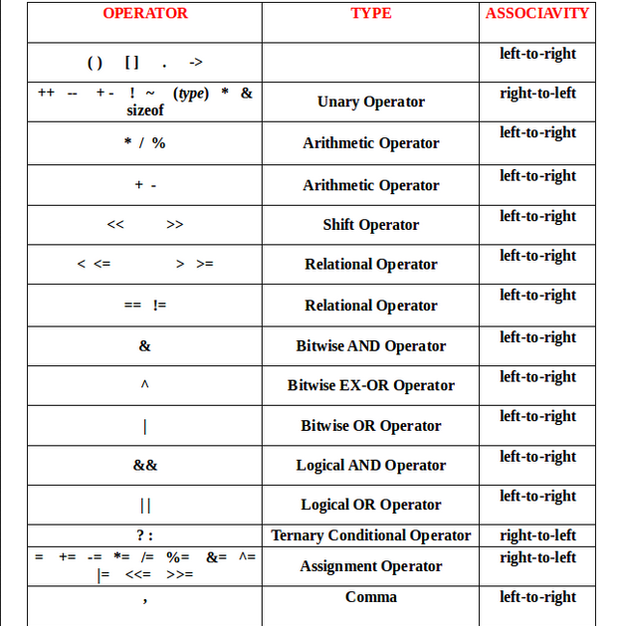

### File Handling:

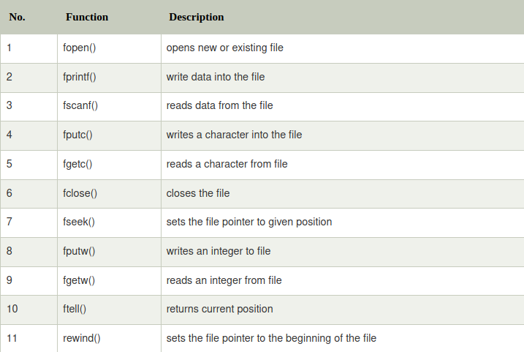

### Preprocessor Directive:

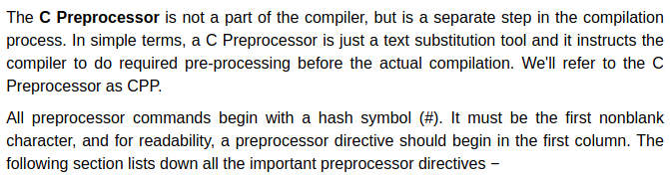

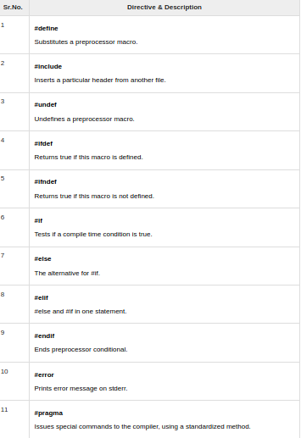

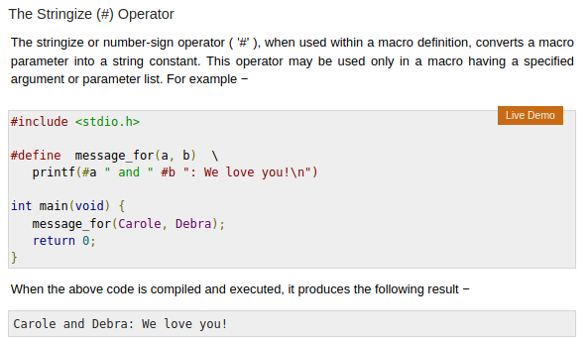

[More](https://www.tutorialspoint.com/cprogramming/c_preprocessors.htm)

### Multithreading:

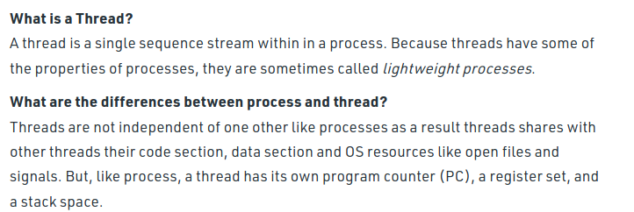

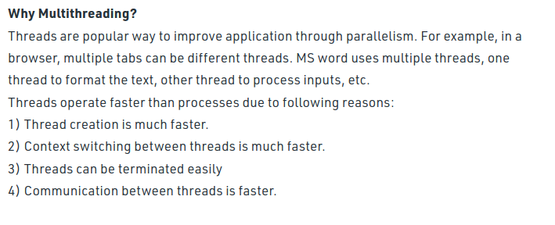





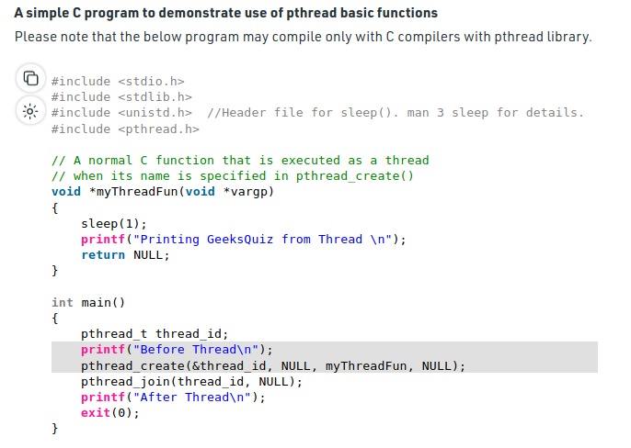

### Assertion:

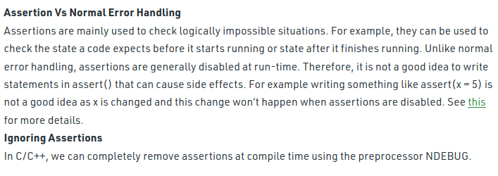

### Hygienic Macros:



 

 